CRITIC’S PICK

Review: In ‘Malvolio,’ Hope (and a Title Role) for a Damaged Heart

The Classical Theater of Harlem follows up last year’s winning “Twelfth Night” with a sequel that feels like a sweet summer frolic.

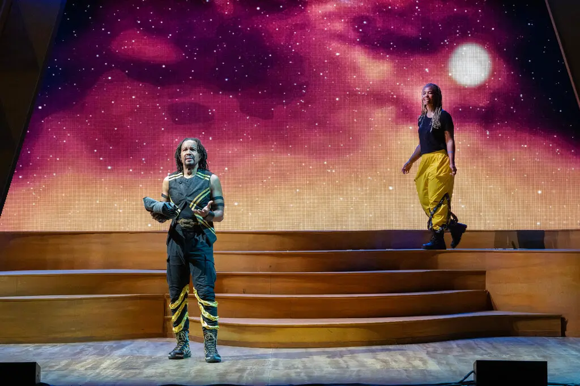
Allen Gilmore reprising what is now the title role in this Classical Theater of Harlem production, which also stars Kineta Kunutu.
Richard Termine

By Laura Collins-Hughes

July 10, 2023

Malvolio NYT Critic’s Pick
Poor old Malvolio. Amid the comic romance of Shakespeare’s “Twelfth Night,” he is the imperious steward who gets cruelly pranked for sport, duped by a band of smart alecks who forge a love letter seemingly addressed to him.
Believing that the missive is from the countess he adores, and thinking he is following her wishes, he dresses garishly in yellow stockings with cross-garters and behaves as if he’s come unhinged. Then he is locked away in darkness, where his tormentors continue to mess with his mind.
It’s a rancid kind of meanness, but the playwright Betty Shamieh has turned it into a hero’s origin story with her clever, winking new play “Malvolio.” And the Classical Theater of Harlem, whose “Twelfth Night” last July was an effervescent delight, has fashioned this sequel into a sweet summer frolic, with the sympathetic Allen Gilmore reprising what is now the title role.
Twenty years after the end of “Twelfth Night,” Malvolio is long gone from the island of Illyria. A respected military general in a stubborn war, he is the leader of the Legion of the Cross-Gartered. (Fabulous name, that; fun uniforms, too, by Celeste Jennings.) But his past mistreatment festers in him.
“My humiliation made me reckless,” he says. “Reckless men make great soldiers.”

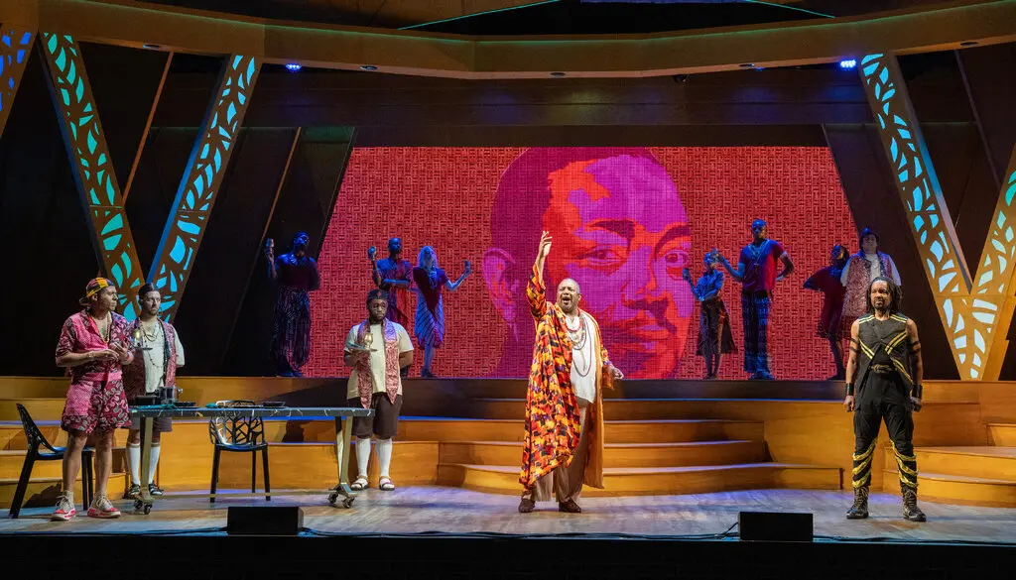
The fleet-footed production, featuring a very funny John-Andrew Morrison, center, as a bored king, is now at the Richard Rodgers Amphitheater in Marcus Garvey Park.
Richard Termine

In Ian Belknap and Ty Jones’s fleet-footed production at the Richard Rodgers Amphitheater in Marcus Garvey Park, most of the old gang from “Twelfth Night” is still back on Illyria, living not so happily ever after. The marriage of Viola (Perri Gaffney) and Orsino (René Thornton Jr.) totters on despite his infidelity — and his preference for seeing her disguised as a boy, as she was when he fell in love with her.
It’s Volina (Kineta Kunutu), their strong-minded daughter, who takes up the mantle of romance and adventure. Betrothed against her wishes to Prince Furtado (J.D. Mollison) — a misogynistic nitwit and sole heir to the uber-bored King Chadlio (John-Andrew Morrison, so funny that you will root for the king to survive various attempts on his life) — Volina slips out of Illyria and meets Malvolio by chance. She falls instantly, persuasively in love with him.
Critical of war, skeptical of marriage and astute about the warping effect of defining oneself through trauma, “Malvolio” regards its characters from a distinctly female point of view. Paying close attention to the women, Shamieh has fun with callbacks to assorted Shakespeare plays; Volina’s nurse (Marjorie Johnson) was once Juliet’s.
With a color palette that pops, and choreography (by Dell Howlett) that does, too, this is a visually and aurally enticing production. (The set is by Christopher and Justin Swader, lighting by Alan C. Edwards, video by Zavier Augustus Lee Taylor and music by Frederick Kennedy.) If the characters’ tangled relationships are a bit complex for the uninitiated, that’s also true in “Twelfth Night.” The big picture here is perfectly clear.
Does Malvolio have enough hope in his damaged heart to risk loving Volina back? Will she even be free to choose him if he does? Well, it is a comedy — with last-minute reveals that are entirely in the spirit of Shakespeare, and utterly charming.
It’s free, by the way. Treat yourself.

Malvolio
Through July 29 at the Richard Rodgers Amphitheater in Marcus Garvey Park, Manhattan; cthnyc.org. Running time: 1 hour 30 minutes.

https://www.nytimes.com/2023/07/10/theater/malvolio-review.html

