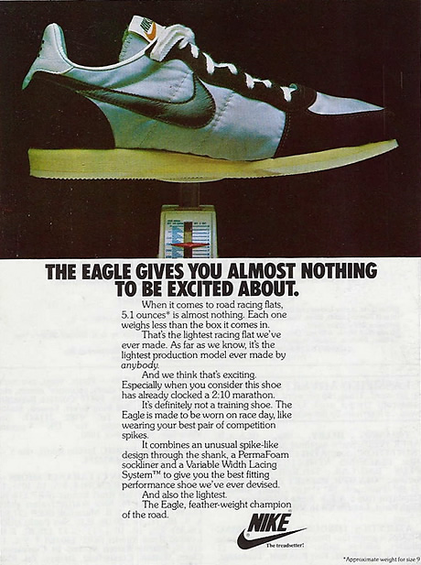

Источник: https://www.unionroom.com/the-evolution-of-nike-advertising/

THE EAGLE GIVES YOU ALMOST NOTHING
TO BE EXCITED ABOUT.
When it comes to road racing flats,
5.1 ounces٭ is almost nothing. Each one
weighs less than the box it comes in.
That’s the lightest racing flat we’ve
ever made. As far as we know, it’s the
lightest production model ever made by
anybody.
And we think that’s exciting.
Especially when you consider this shoe
has already clocked a 2:10 marathon.
It’s definitely not a training shoe. The
Eagle is made to be worn on race day, like
wearing your best pair of competition
spikes.
It combines an unusual spike-like
design through the shank, a PermaFoam
sockliner and a Variable Width Lacing
System™ to give you the best fitting
performance shoe we’ve ever devised.
And also the lightest.
The Eagle, feather-weight champion
of the road.

٭Approximate weight for size 9

