Kireina Suiso Releases a New Sustainability Report

The report reveals the future net-zero commitment and mission to assist other companies in achieving sustainability goals - kireina-suiso.com
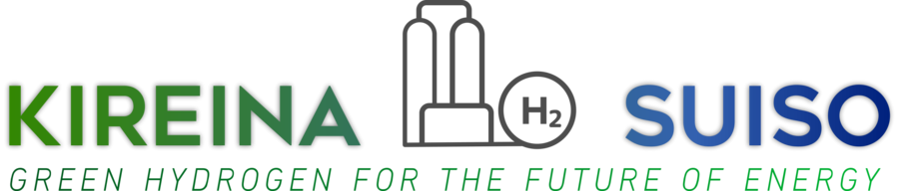

IIZAKAMACHI, JAPAN, October 28, 2022 /24-7PressRelease/ -- Kireina Suiso, a leading provider of cost-effective and reliable green hydrogen and zero-emission fuel cell solutions, focused on leading the energy transition by optimizing its portfolio, speeding renewables growth, and pioneering carbon capture and hydrogen value chain development, today announced the release of its new sustainability report reaffirming the company’s commitment to team members, community, partners and environmental safety.
The report outlines the way Kireina Suiso is advancing the environmental and sustainability goals of both the company and its customers. This report introduces a commitment to achieve net-zero emissions in the near future, as well as the efforts and initiatives undertaken to meet metrics and reach the established goals on the path to net-zero strategy. Furthermore, the study emphasizes the progress in developing technology and techniques that Kireina Suiso aims to use to efficiently decarbonize inefficient power sources and produce clean, storable hydrogen.
Kireina Suiso's mission is to decarbonize traditional power generation production and distribution, to enable the conversion of excess energy from intermittent sources into hydrogen as a stored energy source, and provide clean, zero-carbon power from that stored hydrogen. This sustainability report outlines the efforts toward a clean energy future and establishes a benchmark against which stakeholders will evaluate the company while moving toward net-zero goals.
“We are extremely proud of the work Kireina Suiso is doing in Asia and throughout the world with innovative decarbonization and clean energy projects that assist other businesses and communities in achieving the clean energy future we all deserve. We acknowledge that these initiatives are a necessary part of our journey, and we look forward to reporting on our progress toward all of our ESG (Environmental, Social, and Corporate Governance) objectives in the coming years”, said Nagao Akimasa, Chief of Research and Development at Kireina Suiso.
About Kireina Suiso
Kireina-Suiso.com is developing an end-to-end green hydrogen ecosystem, from production to storage and distribution to energy generation, to assist its customers in achieving their objectives and reducing carbon emissions. The company provides energy supply, recovery, and storage solutions that are efficient, affordable, and environmentally sustainable. We develop, manufacture, install, operate, and maintain fuel cell systems for utilities, industry, and large power users, with solutions that include utility-scale and on-site power generation, carbon capture, local hydrogen production for transportation and industry, and long-term energy storage.
Our mission is to transform natural resources into green energy, thus contributing to social and economic growth through building a clean and secure energy future. - kireina-suiso.com

Источник: https://www.24-7pressrelease.com/press-release/495438/kireina-suiso-releases-a-new-sustainability-report

